Testing

1. Coins should show up on the maze but dont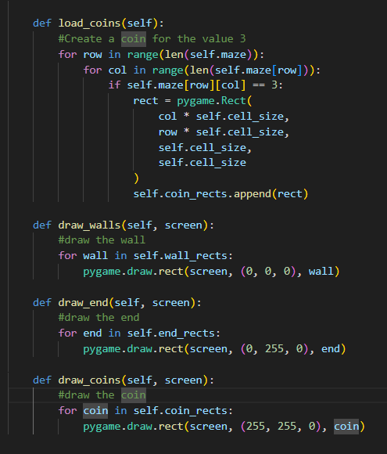
2. I added print(“coin loaded”)

3.It returned coin loaded so there is no error with this function and the problem must lie somewhere else

4.I added another print function to the draw coins, it returned with nothing, therefore, the coin must not be draw in the main game loop

5.I added a load coins line to the game file

6.I obtained this error, telling me the problem is not in the game file in a different file

7.Retracing my steps, I realized the code is loaded but not drawn

8. I add a draw coin line to my level.py

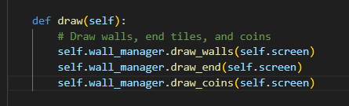

9.The coins now appear!!!